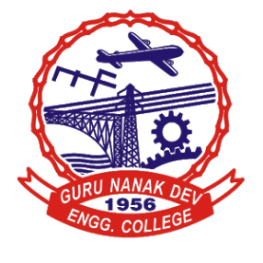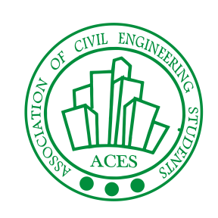**Event Report**

**Event – “GROUP DISCUSSION”**

On Tuesday, 25th February, 2020 an activity was organised in Guru Nanak Dev Engineering College, Ludhiana. Under ACES (Association of Civil Engineering Students) in Testing and Consultancy Cell Hall.

The aim of group discussion competition was to enhance the learning in both effective and cognitive domains. It enhance communication skills, leadership quality and thinking capacity.

Total number of participants were 42 students.

The Topics discussed in the event are :

1. JOBS VS ENTREPRENEURSHIP.
2. PRIVATISATION CAUSES LESS CORRUPTION. DISCUSS!
3. VILLAGES ARE THE PRIDE OF INDIA.
4. INDIAN POLITICS ARE THE REASON BEHIND COUNTRY’S BACKWARDNESS.
5. A BIG BLACK DOT ON A WHITE PAPER.

The Event was judged by Prof. Yuvraj Singh,Prof. Sukwinder Pal Singh and Prof. Manmeet Kaur.

Event was conducted successively and the winners were honoured with mementos and the participants with participation certificate.

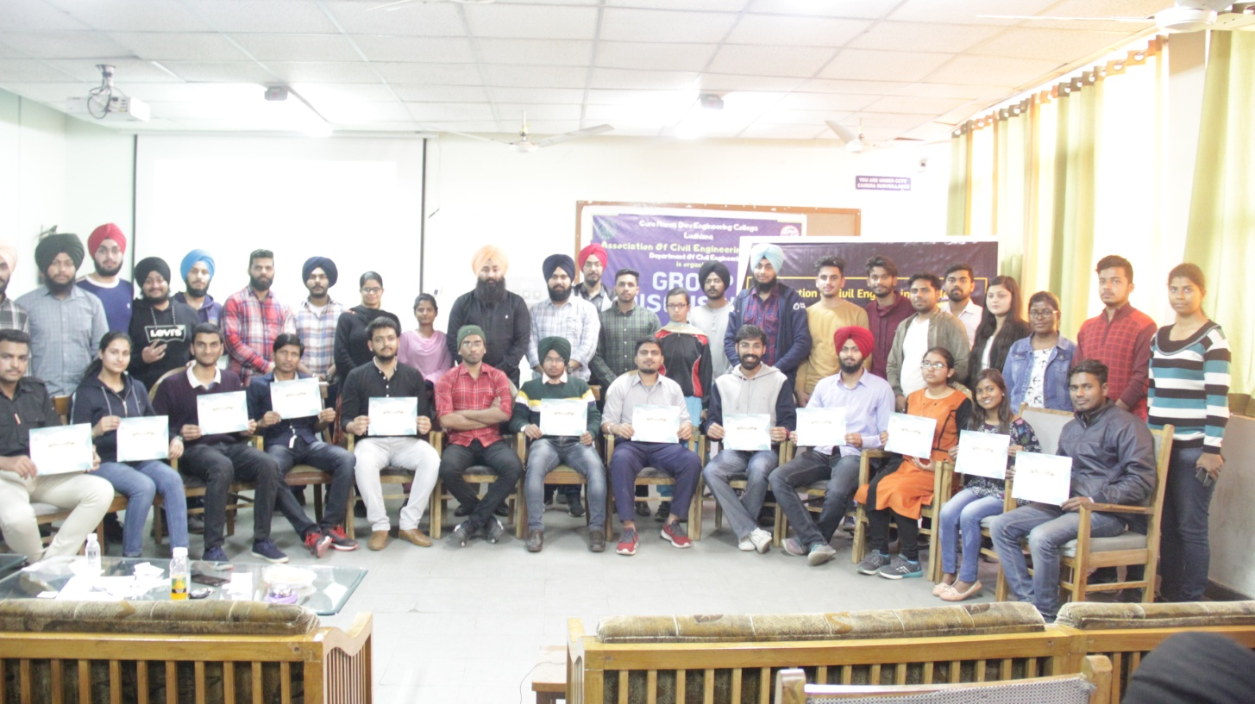

Organizers of the Event

|  |  |  |
| --- | --- | --- |
| **Name** | **Year** | **Roll No.** |
| Mehakdeep Singh Sandhu | D1 | 1904884 |
| Aashu Kumari | D1 | 1904801 |
| Sharanjit Singh | D1 | 1904922 |
| Ritik Sagar Nishad | D1 | 1904905 |
| Ananya Verma | D1 | 1904816 |
| Shiv Pratap Dubey | D1 | 1904925 |
| Nikhil | D1 | 1904890 |
| Abhishek Thakur | D2 | 1804999 |
| Japjyot Singh | D2 | 1814050 |
| Ujjwaldeep Singh | D2 | 1805117 |
| Charanpreet Singh | D2 | 1805029 |
| Minkle Motan | D2 | 1904962 |
| Altmash Salman Mirza | D2 | 1805005 |
| Manpreet Singh Bains | D2 | 1805076 |
| Amanpreet Kaur | D2 | 1805008 |

**JUDGES :**

Prof. Yuvraj Singh

Prof. Sukhwinderpal Singh

Prof. Manmeet Kaur

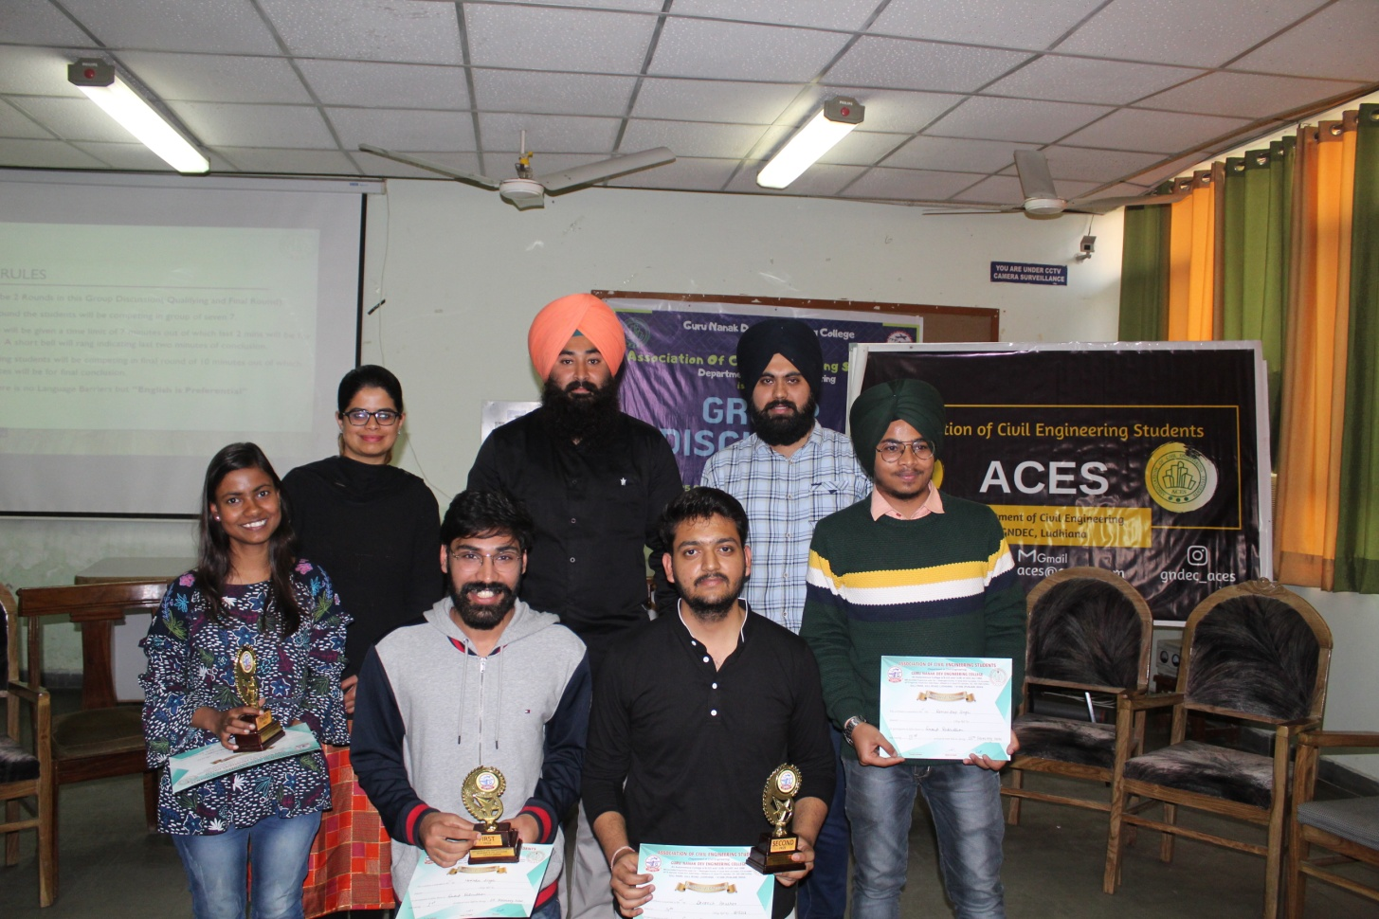

**WINNERS**

|  |  |  |  |
| --- | --- | --- | --- |
| **Name** | **CRN** | **BRANCH** | **POSITION** |
| Harinder Singh | 1606680 | CSE | 1st |
| Devansh Bhushan | 1815013 | CSE | 2nd |
| Ramandeep Singh | 1614152 | CE | 3rd |
| Astha | 1921016 | CE | 3rd |